1. Acuna Cactus Endangered Arizona, Mx

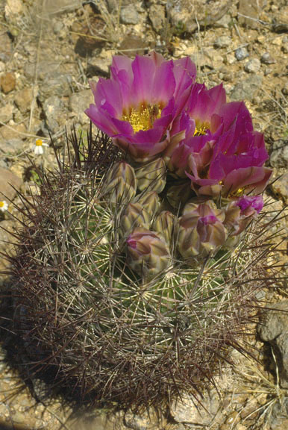
https://ecos.fws.gov/ecp0/profile/speciesProfile?spcode=Q0OU

2. Arroyo Toad Endangered CA

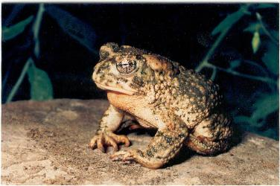
https://ecos.fws.gov/ecp0/profile/speciesProfile?spcode=D020

3. Ashy Dogweed Texas
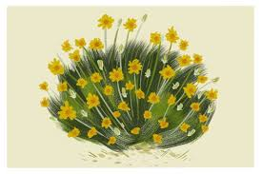
https://tpwd.texas.gov/huntwild/wild/wildlife_diversity/nongame/listed-species/plants/ashy_dogweed.phtml

4. Bald Eagle Recovering but threatened by border TX, AZ

https://www.allaboutbirds.org/guide/Bald_Eagle/overview

5. Bartram Stonecrop Under Review AZ

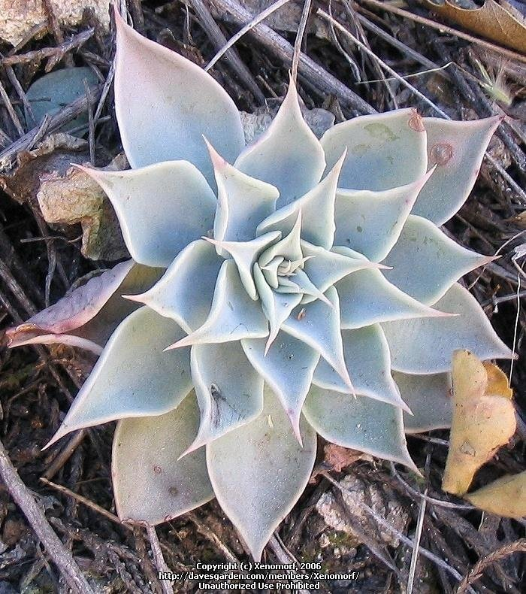
https://en.wikipedia.org/wiki/Graptopetalum_bartramii

6. Beardless Chinchweed Under Review AZ

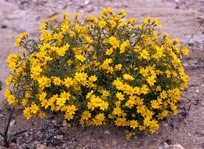

https://ecos.fws.gov/ecp0/profile/speciesProfile?spcode=Q2Q9

7. Beautiful Shiner Threatened AZ, NM

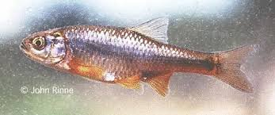
https://ecos.fws.gov/ecp0/profile/speciesProfile?sId=7874

8. Big Bend Gambusia Endangered TX

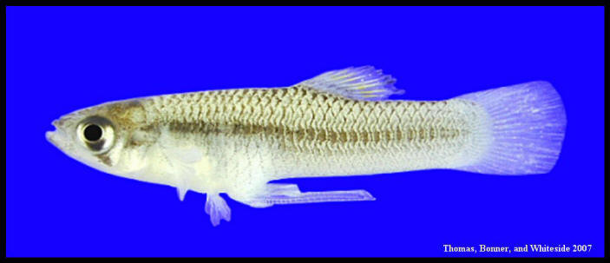
https://www.biologicaldiversity.org/campaigns/esa_works/profile_pages/BigBendGambusia.html

9. Black Capped Vireo Endangered TX

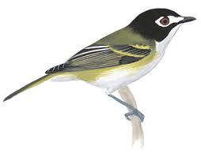
https://www.audubon.org/field-guide/bird/black-capped-vireo

10. Bunched Cory Cactus Threatened TX

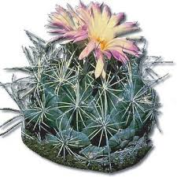
https://tpwd.texas.gov/huntwild/wild/wildlife_diversity/nongame/listed-species/plants/bunched_cory_cactus.phtm

11. Cactus Ferruginous Pgymy Owl Review AZ

https://cdn.audubon.org/cdn/farfuture/XA07elP9vge9rrZL3ZD5HMAStVhwO9NY3YyR3rv7p6Q/mtime:1416244626/sites/default/files/FEPYOW_1.tootingsong_MEXms.mp3?uuid=5c5d6d126e8ab

12. California Condor Endangered AZ

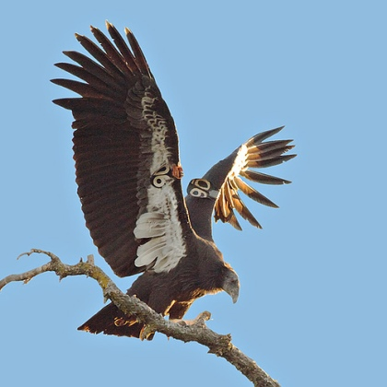
https://www.allaboutbirds.org/guide/California_Condor/id

13. California Least Tern Endangered AZ

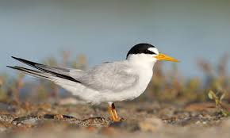
https://www.fws.gov/sacramento/es_species/Accounts/Birds/ca_least_tern/

14. California Orcutt Grass

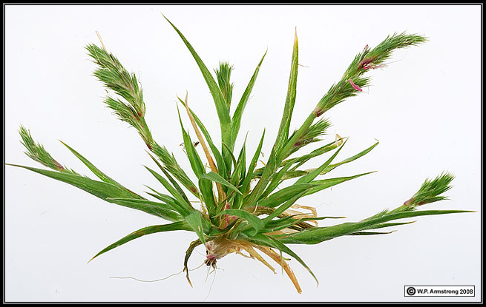
https://ecos.fws.gov/ecp0/profile/speciesProfile?spcode=Q1ZO

15. Chiricahua Leopard Frog Threatened AZ, NM

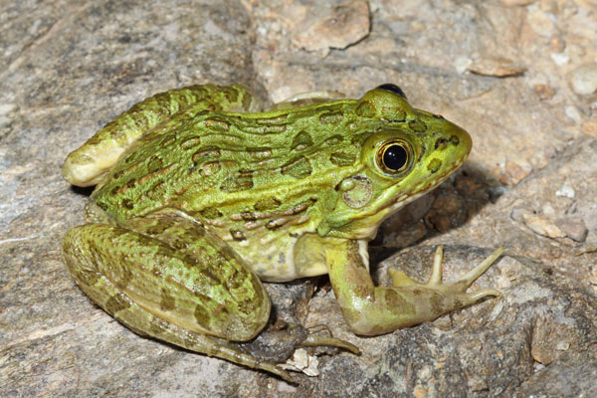
https://www.biologicaldiversity.org/species/amphibians/Chiricahua_leopard_frog/

16. Chisos Mountain Hedgehog Cactus Threatened TX

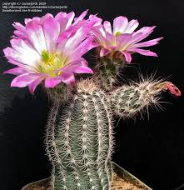
https://tpwd.texas.gov/huntwild/wild/wildlife_diversity/nongame/listed-species/plants/chisos_mountains_hedgehog_cactus.phtml

17. Coastal California Gnatcatcher

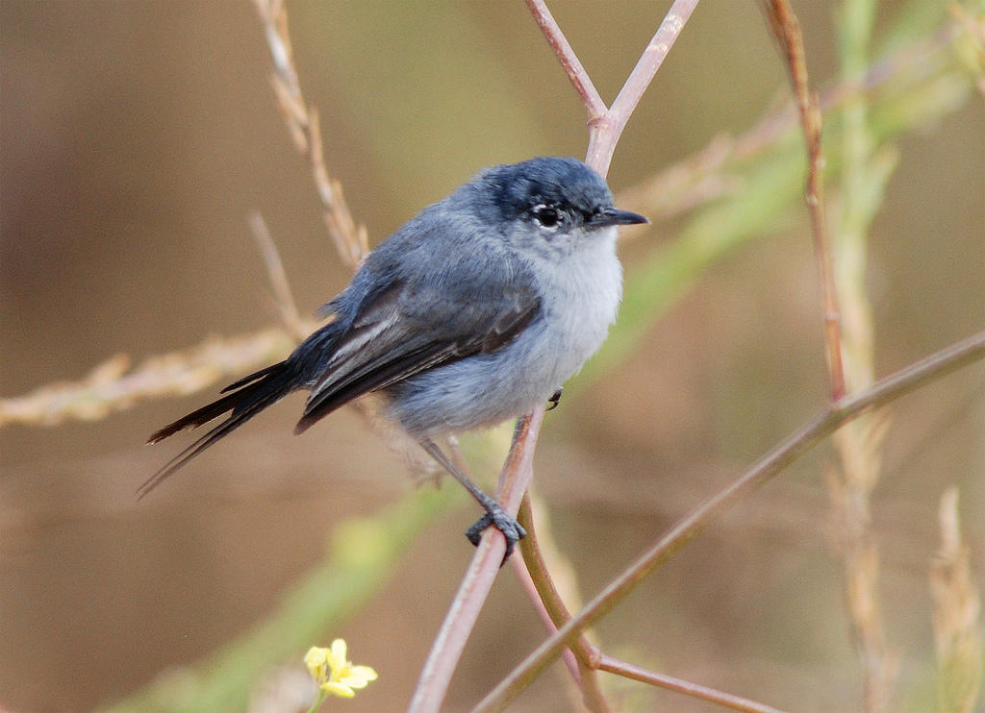
https://www.audubon.org/field-guide/bird/california-gnatcatcher

18. Cochise Pincushion Cactus Threatened AZ

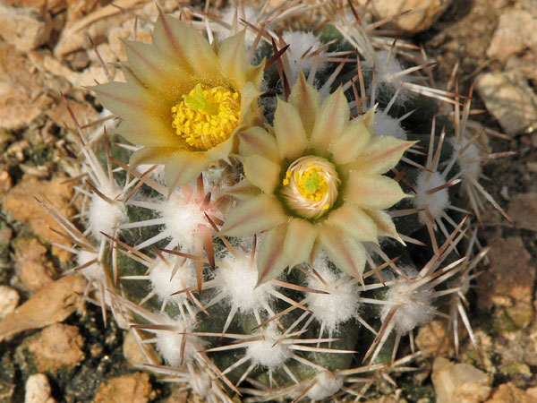

https://ecos.fws.gov/ecp0/profile/speciesProfile?sId=7229

19. Del Mar Manzanita

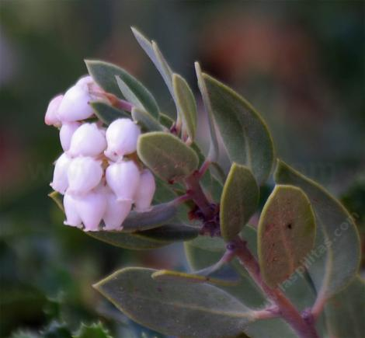
https://ecos.fws.gov/ecp0/profile/speciesProfile?spcode=Q036

20. Devils River Minnow Theatened TX

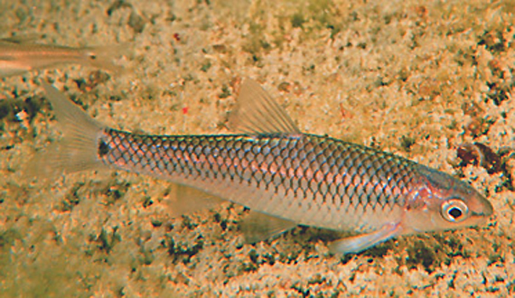
https://www.biologicaldiversity.org/species/fish/Devils_River_minnow/index.html

21. Gila Chub Endangered AZ

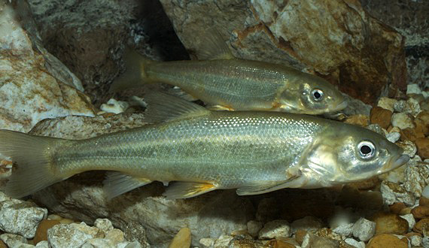
https://www.biologicaldiversity.org/species/fish/Gila_chub/index.html

22. Gila Topminnow Endangered AZ, NM

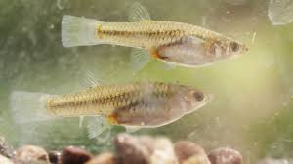
https://nas.er.usgs.gov/queries/FactSheet.aspx?speciesID=866

23. Golden Eagle Vulnerable TX

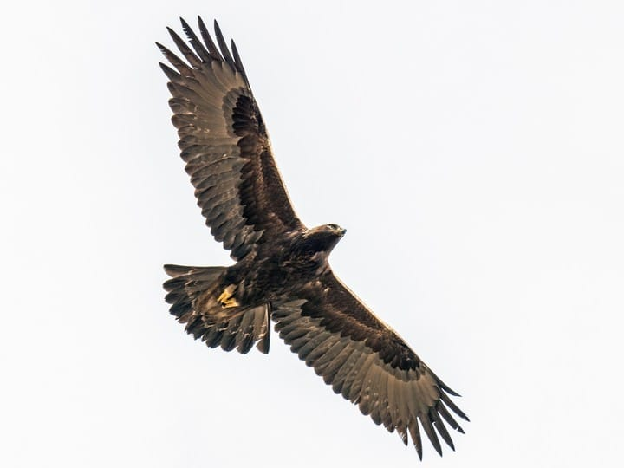
https://www.allaboutbirds.org/guide/Golden_Eagle/id

24. Gaudalupe Fescue Proposed Endangered TX
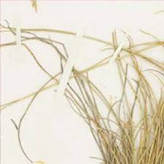
https://ecos.fws.gov/ecp0/profile/speciesProfile?spcode=Q0UM

25. Gulf Coast Jaguarundi Endangered TX

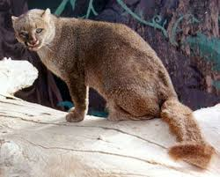
https://ecos.fws.gov/ecp0/profile/speciesProfile?sId=3945

26. Hermes Copper Butterfly

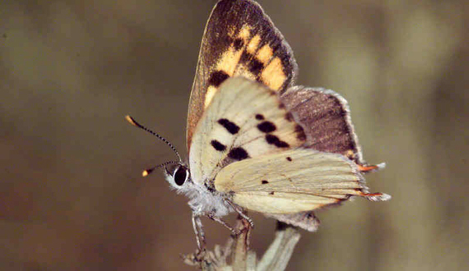
https://www.biologicaldiversity.org/species/invertebrates/Hermes_copper_butterfly/index.html

27. Hinckley Oak Threatened TX

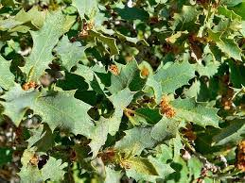
https://tpwd.texas.gov/huntwild/wild/wildlife_diversity/nongame/listed-species/plants/hinckleys_oak.phtml

28. Huachuca Water Umbel Endangered AZ
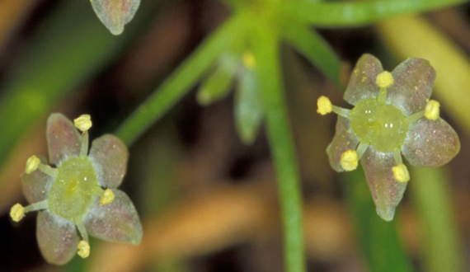
https://www.biologicaldiversity.org/species/plants/Huachuca_water_umbel/

29. Jaguar - El Tigre Endangered AZ, NM

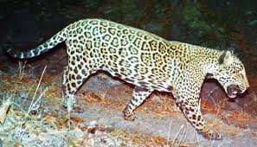
https://www.thedailybeast.com/trumps-wall-threatens-last-jaguars-in-the-us

30. Kearney’s Blue-star Endangered AZ
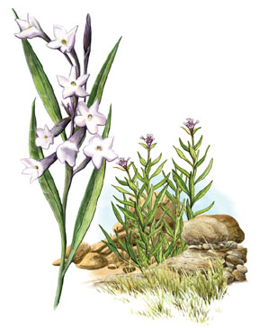

https://ecos.fws.gov/ecp0/profile/speciesProfile?sId=7485

31. Laguna Mountains Skipper

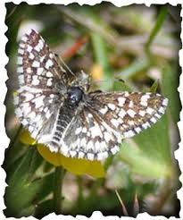

https://ecos.fws.gov/ecp0/profile/speciesProfile?spcode=I0LW

32. Least Bell’s Vireo

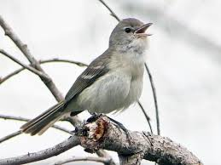
https://ecos.fws.gov/ecp0/profile/speciesProfile?spcode=B067

33. Least Tern Endangered NM, TX

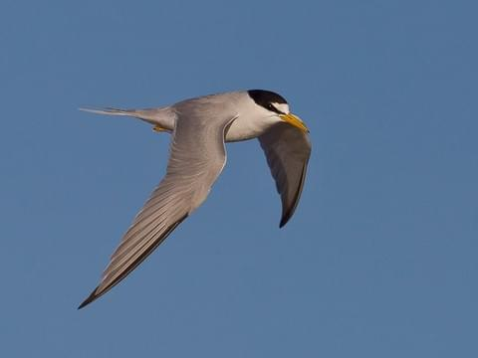
https://www.allaboutbirds.org/guide/Least_Tern/overview

34. Leatherback Sea Turtle Endangered CA, TX
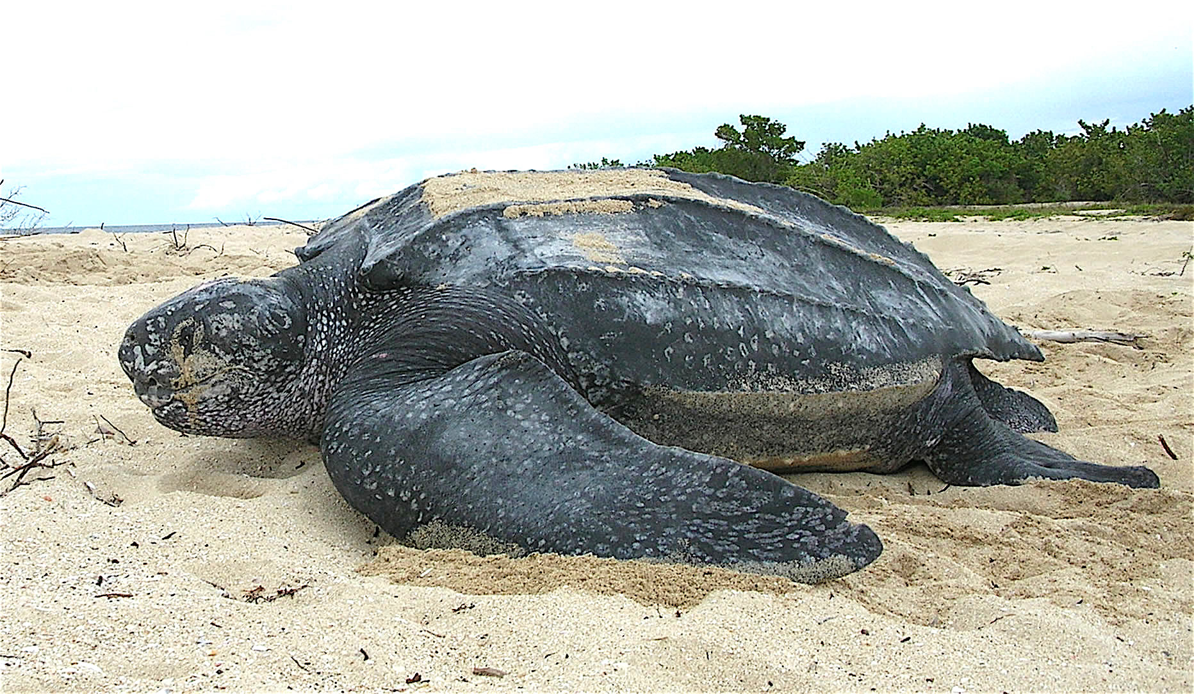
https://www.nationalgeographic.com/animals/reptiles/l/leatherback-sea-turtle/

35. Lesser Long-Nosed Bat – no longer endangered but at risk AZ, TX

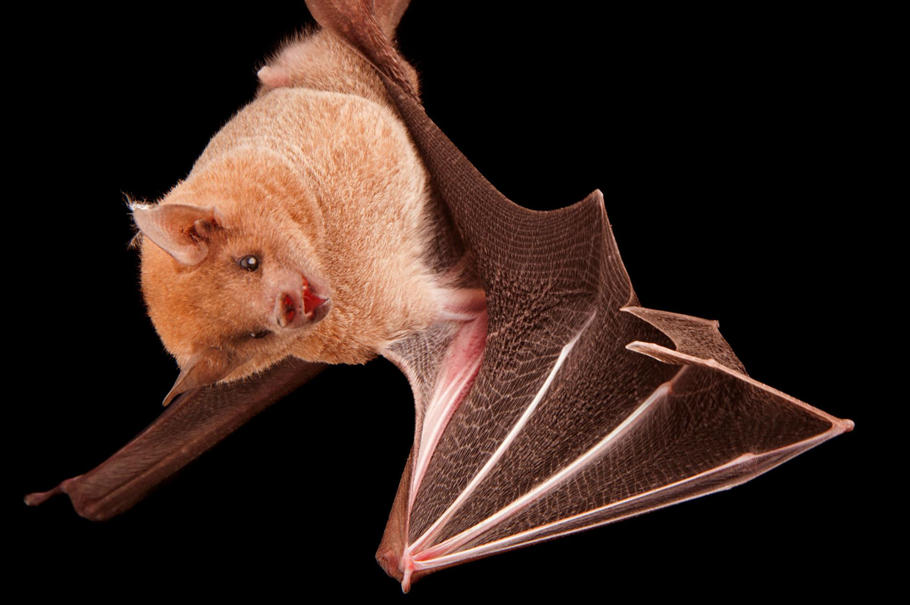
https://news.nationalgeographic.com/2018/04/lesser-long-nosed-bats-conservation-delisted-endangered-animals-spd/

36. Light Footed Clapper Rail

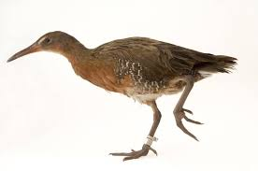
https://ecos.fws.gov/ecp0/profile/speciesProfile?spcode=B04B

37. Lloyd’s Mariposa Cactus Threatened TX

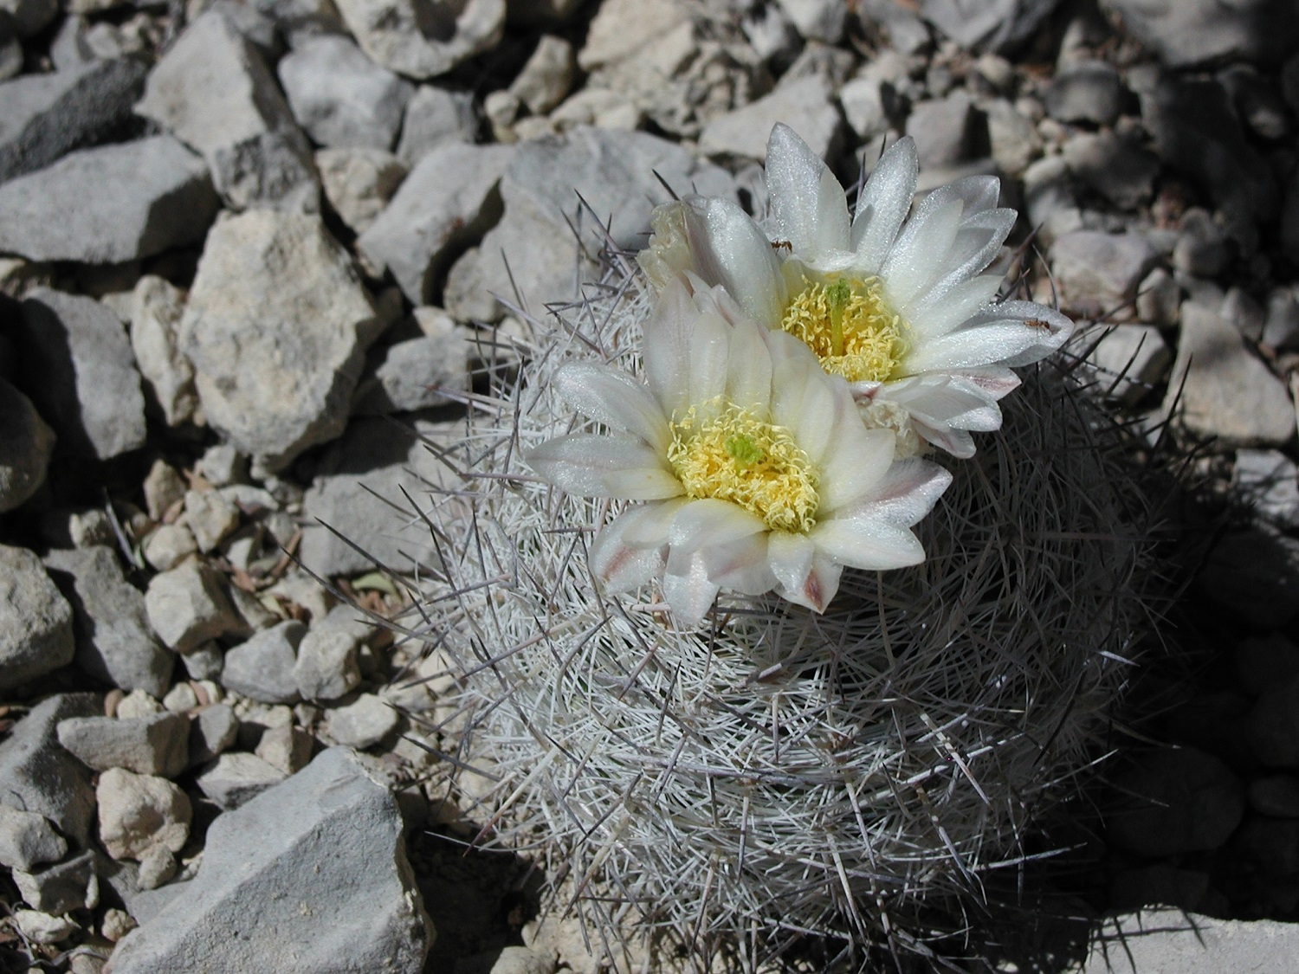
https://tpwd.texas.gov/huntwild/wild/wildlife_diversity/nongame/listed-species/plants/lloyds_mariposa_cactus.phtml

38. Loach Minnow ENDANGERED AZ, NM

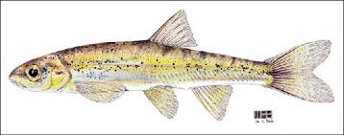
https://www.biologicaldiversity.org/species/fish/loach_minnow/index.html

39. Loggerhead Sea Turtle Threateded/Endangered CA, TX

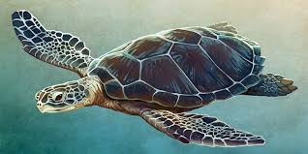
https://www.nationalgeographic.com/animals/reptiles/l/loggerhead-sea-turtle/

40. Masked Bob White Endangered AZ

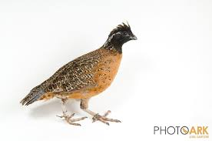
https://wildearthguardians.org/wildlife-conservation/endangered-species-list/birds/masked-bobwhite/

41. Mexican Flannelbush

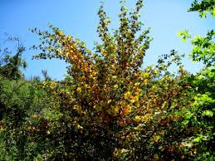
http://earthsendangered.com/profile.asp?sp=1279&ID=9

42. Mexican (Greater) Long-Nosed Bat Endangered NM, TX

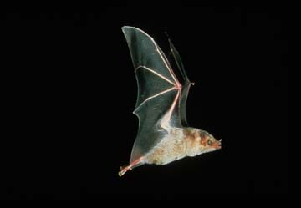
https://ecos.fws.gov/ecp0/profile/speciesProfile?spcode=A0AE

43. Mexican Spotted Owl Threatened AZ, NM, TX

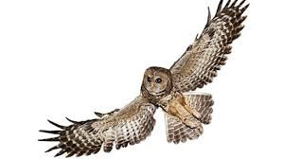
https://www.nps.gov/articles/mexican-spotted-owl.htm

44. Mexican Grey Wolf - el Lobo Endangered NM, AZ

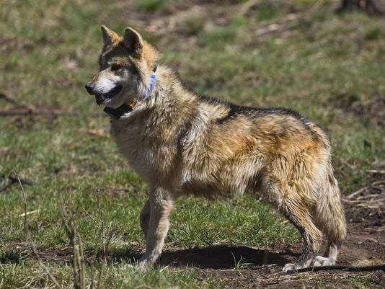
https://www.biologicaldiversity.org/species/mammals/Mexican_gray_wolf/

45. Narrow Headed Garter Snake Threatened NM

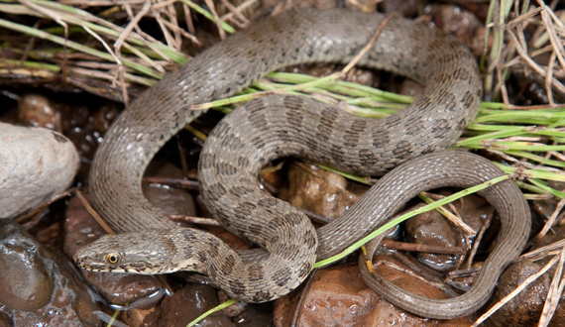
https://www.biologicaldiversity.org/species/reptiles/narrow-headed_garter_snake/index.html

46. Nellie Cory Cactus Endangered TX

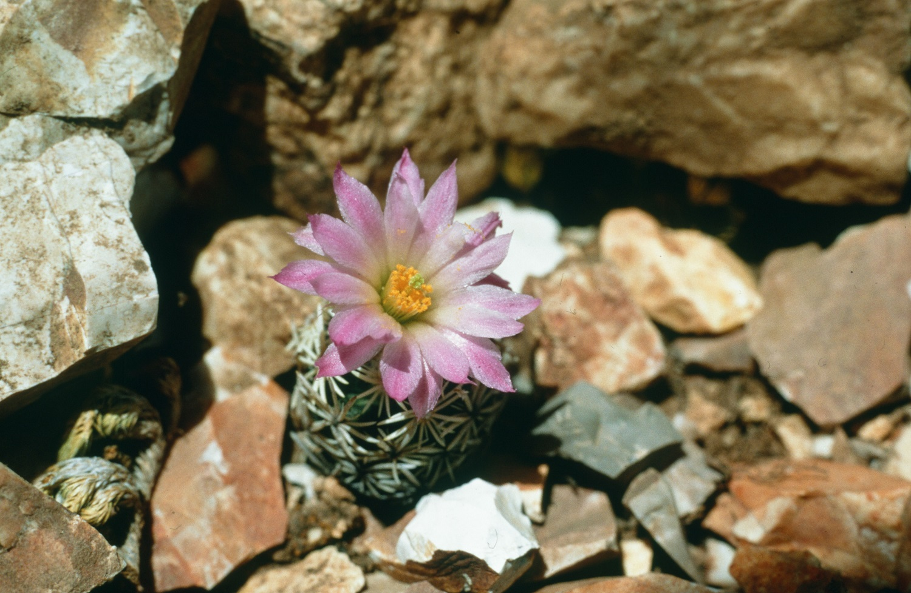
https://tpwd.texas.gov/huntwild/wild/wildlife_diversity/nongame/listed-species/plants/nellies_cory_cactus.phtml

47. New Mexican Ridge-Nosed Rattlesnake Threatened NM, AZ

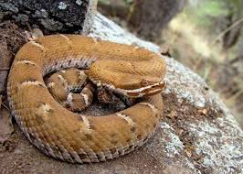
https://ecos.fws.gov/ecp0/profile/speciesProfile?sId=3657

48. Nichol’s Turk’s Head Cactus Endangered AZ
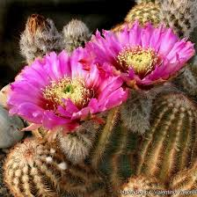
https://cals.arizona.edu/herbarium/content/nichols-turks-head-cactus-working-group

49. Northern Aplomado Falcon Endangered AZ, NM, TX

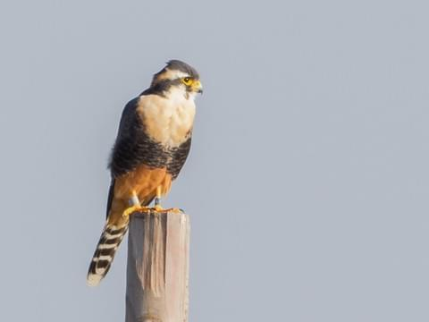
https://www.allaboutbirds.org/guide/Aplomado_Falcon/overview

50. Northern Mexican Garter Snake Threatened AZ, NM

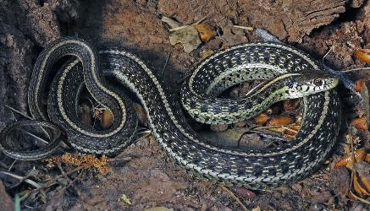
https://ecos.fws.gov/ecp0/profile/speciesProfile?spcode=C04Q

51. Ocelot Endangered AZ, TX

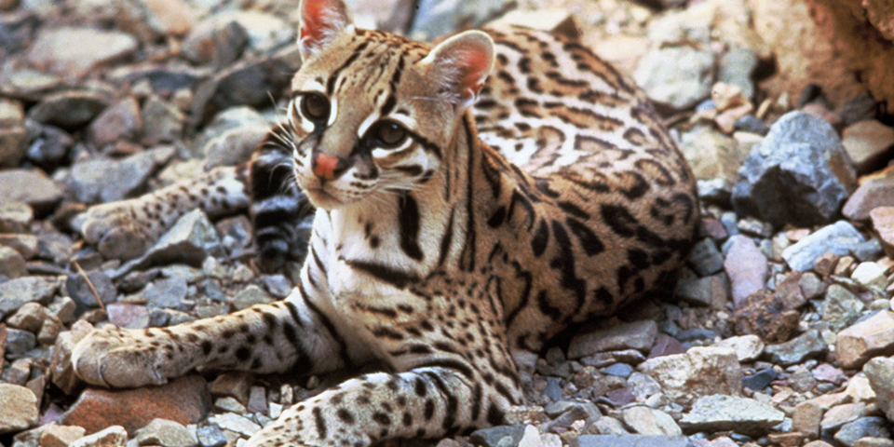
https://defenders.org/ocelot/basic-facts

52. Otay Mesa Mint Endangered

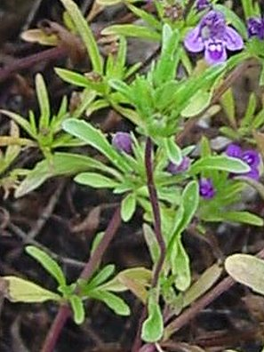
https://ecos.fws.gov/ecp0/profile/speciesProfile?sId=5362

53. Otay Tar Plant Threatened

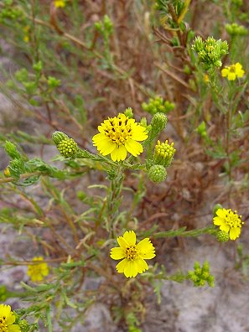
https://ecos.fws.gov/ecp0/profile/speciesProfile?spcode=Q0YQ

54. Pacific Pocket Mouse

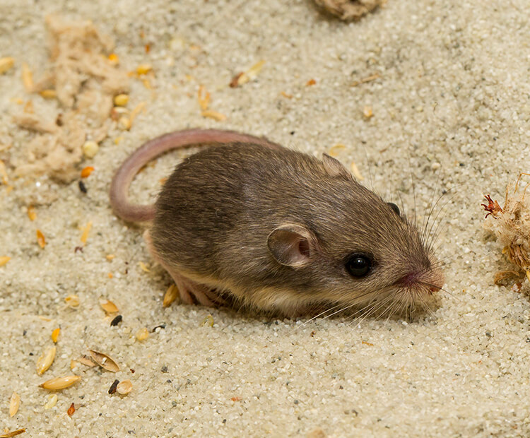
https://www.biologicaldiversity.org/species/mammals/Pacific_pocket_mouse/

55. Pierson’s Milk Vetch

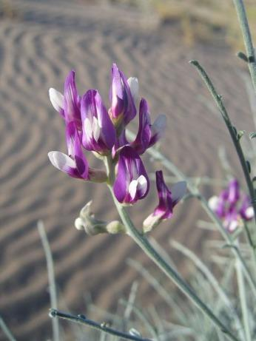
https://www.wildlife.ca.gov/Conservation/Plants/Endangered/Astragalus-magdalenae-var-peirsonii

56. Peninsular Big Horn Sheep

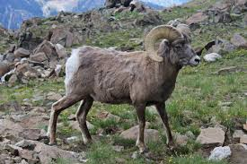
https://www.wildlife.ca.gov/Conservation/Mammals/Bighorn-Sheep/Desert/Peninsular

57. Pima Pineapple Cactus Endangered AZ

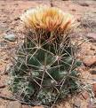
http://www.indefenseofplants.com/blog/2018/2/27/the-pima-pineapple-cactus

58. Piping Plover Threatened TX
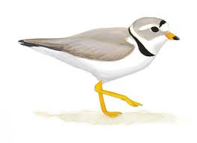
https://www.audubon.org/field-guide/bird/piping-plover

59. Quino Checkerspot Butterfly

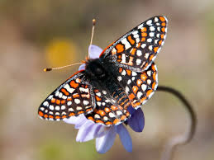
https://www.biologicaldiversity.org/species/invertebrates/Quino_checkerspot_butterfly/index.html

60. Quitobaquito Pupfish Endangered AZ

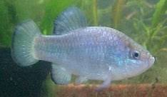
https://www.iucnredlist.org/species/191303/15361760

61. Razorback Sucker Endangered CA, AZ

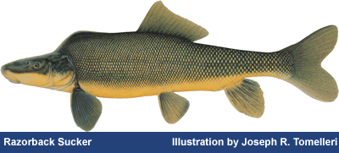
https://www.fws.gov/nevada/protected_species/fish/species/rzbk_sucker.html

62. Red Crowned Parrot Review TX

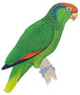
https://www.audubon.org/field-guide/bird/red-crowned-parrot

63. Rio Grande Silvery Minnow Endangered NM

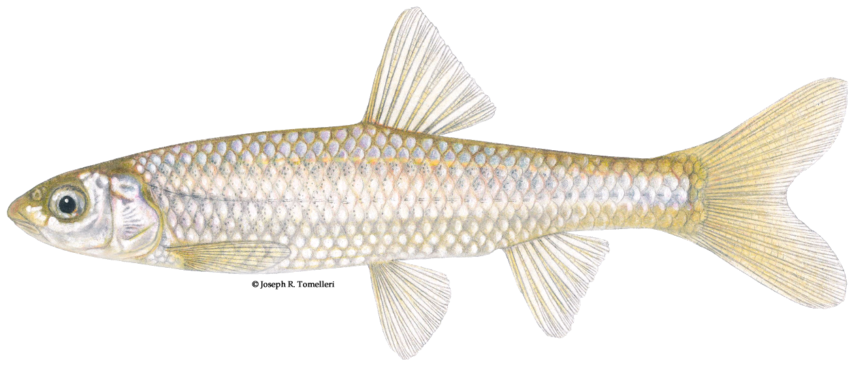
https://www.fws.gov/fisheries/freshwater-fish-of-america/rio_grande_silvery_minnow.html

64. Riverside Fairy Shrimp

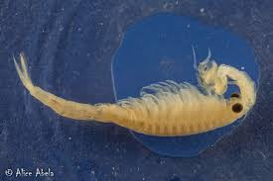
https://www.biologicaldiversity.org/species/invertebrates/Riverside_fairy_shrimp/index.html

65. Saltmarsh Birds Beak

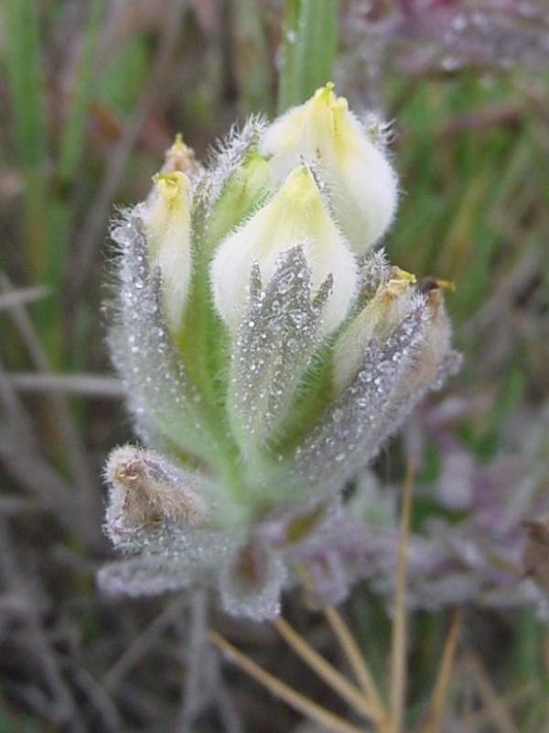
https://ecos.fws.gov/ecp0/profile/speciesProfile?spcode=Q1US

66. San Bernadino Spring Snail Threatened AZ

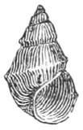
https://www.iucnredlist.org/species/18991/1939708

67. San Diego Ambrosia

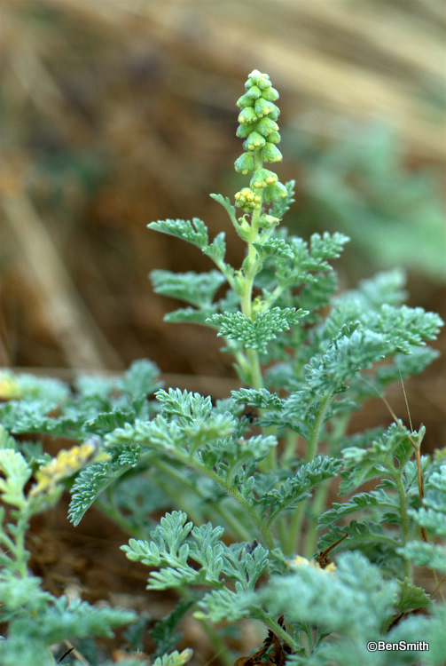
https://www.biologicaldiversity.org/species/plants/San_Diego_ambrosia/index.html

68. San Diego Button Celery

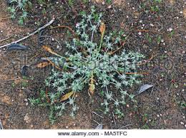
https://ecos.fws.gov/ecp0/profile/speciesProfile?spcode=Q1W9\

69. San Diego Fairy Shrimp

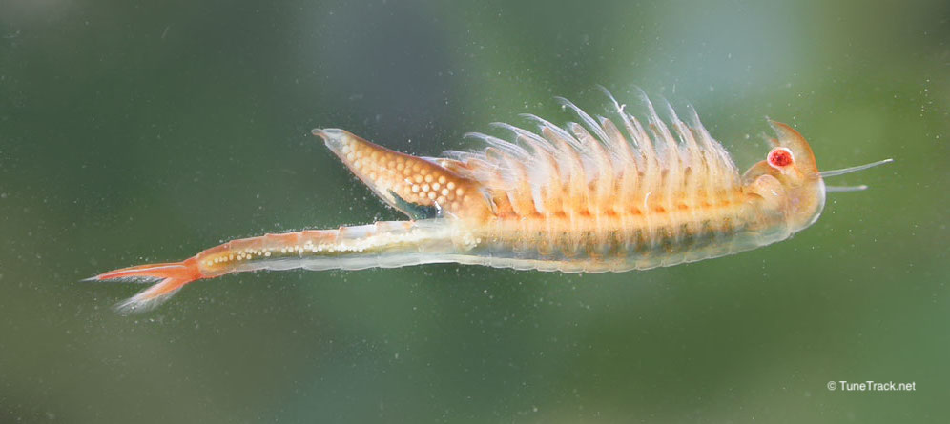
https://ecos.fws.gov/ecp0/profile/speciesProfile?spcode=K049

70. San Diego Thorn Mint

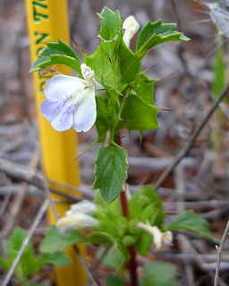
https://www.wildlife.ca.gov/Conservation/Plants/Endangered/Acanthomintha-ilicifolia

71. Sonora Chub Threatened AZ

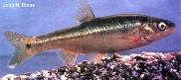
https://ecos.fws.gov/ecp0/profile/speciesProfile?spcode=E029

72. Sonoran Pronghorn Endangered AZ

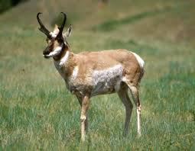
https://defenders.org/sonoran-pronghorn/basic-facts

73. Sonoran Talus Snail Under Review AZ

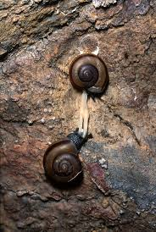
https://www.biologicaldiversity.org/species/invertebrates/pdfs/Talussnails_Petition.pdf

74. Sonoran Tiger Salamander

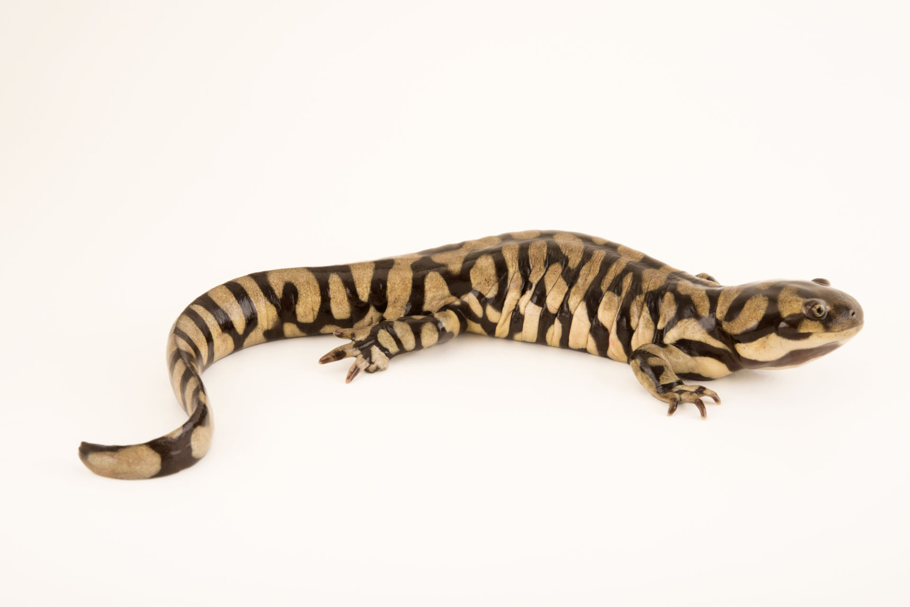
https://ecos.fws.gov/ecp0/profile/speciesProfile?spcode=D01H

75. Sonoyta Mud Turtle Proposed Endangered AZ

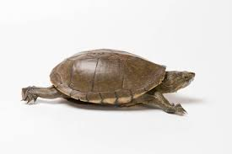
https://www.biologicaldiversity.org/species/reptiles/Sonoyta_mud_turtle/index.html

76. South Texas Ambrosia Endangered TX

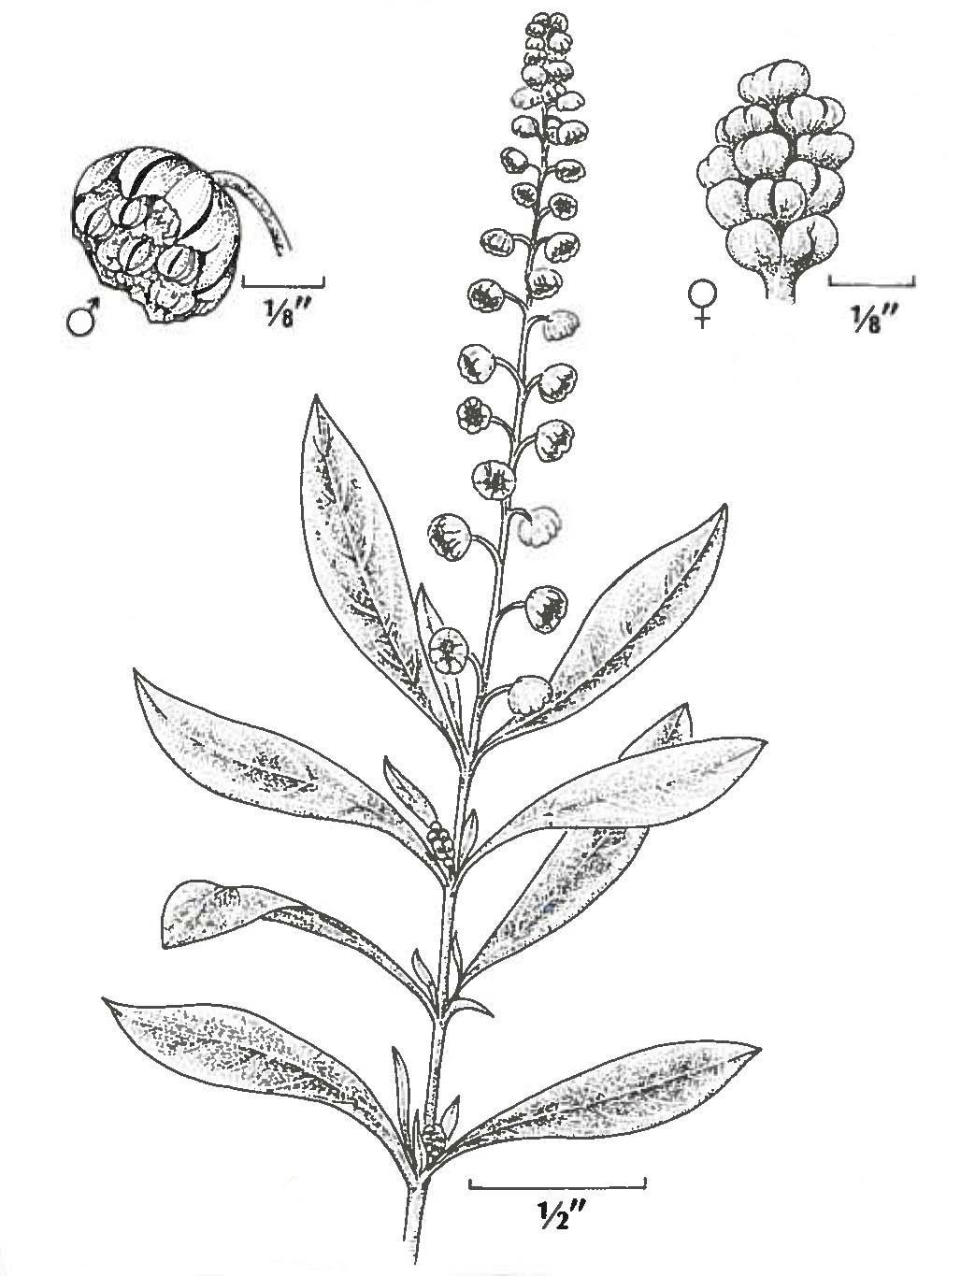
https://tpwd.texas.gov/huntwild/wild/wildlife_diversity/nongame/listed-species/plants/south_texas_ambrosia.phtml

77. Southwestern Willow Flycatcher Endangered AZ, NM, TX

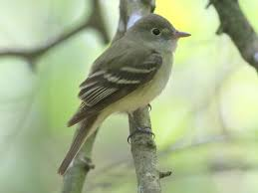
https://www.biologicaldiversity.org/species/birds/southwestern_willow_flycatcher/

78. Spikedace Endangered AZ, NM

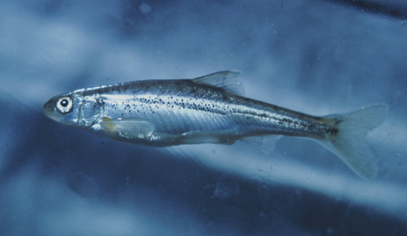
https://www.biologicaldiversity.org/species/fish/spikedace/index.html

79. Spreading Navarretia

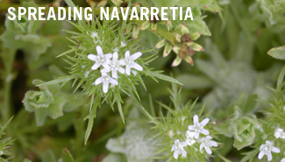
https://www.biologicaldiversity.org/species/plants/spreading_navarretia/index.html

80. Star Cactus Endangered TX

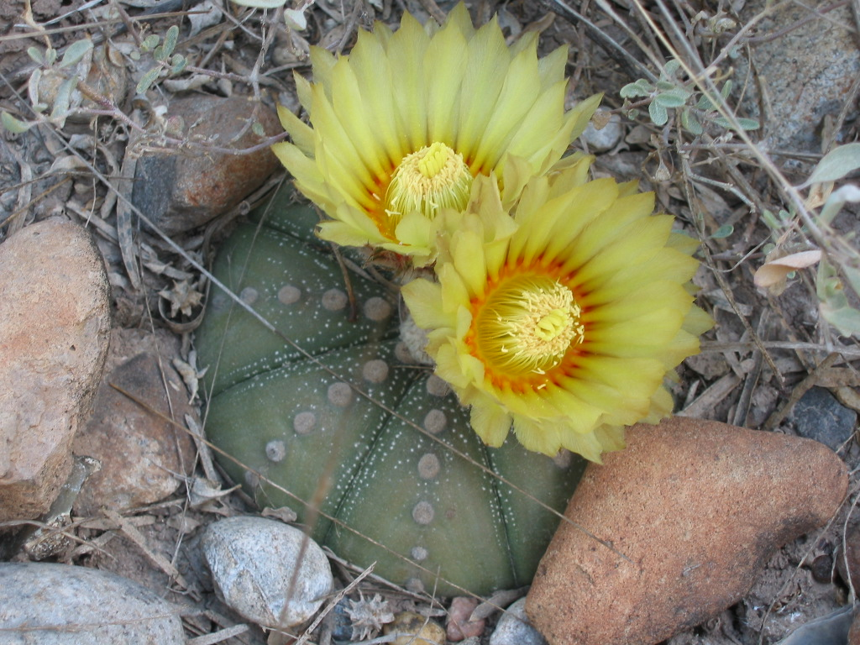
https://tpwd.texas.gov/huntwild/wild/wildlife_diversity/nongame/listed-species/plants/star_cactus.phtml

81. Southern California Steelhead Trout

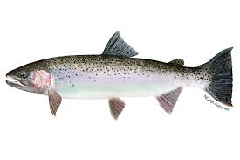
https://www.biologicaldiversity.org/species/fish/southern_California_steelhead_trout/index.html

82. Terlingua Creek Cats Eye Endangered TX

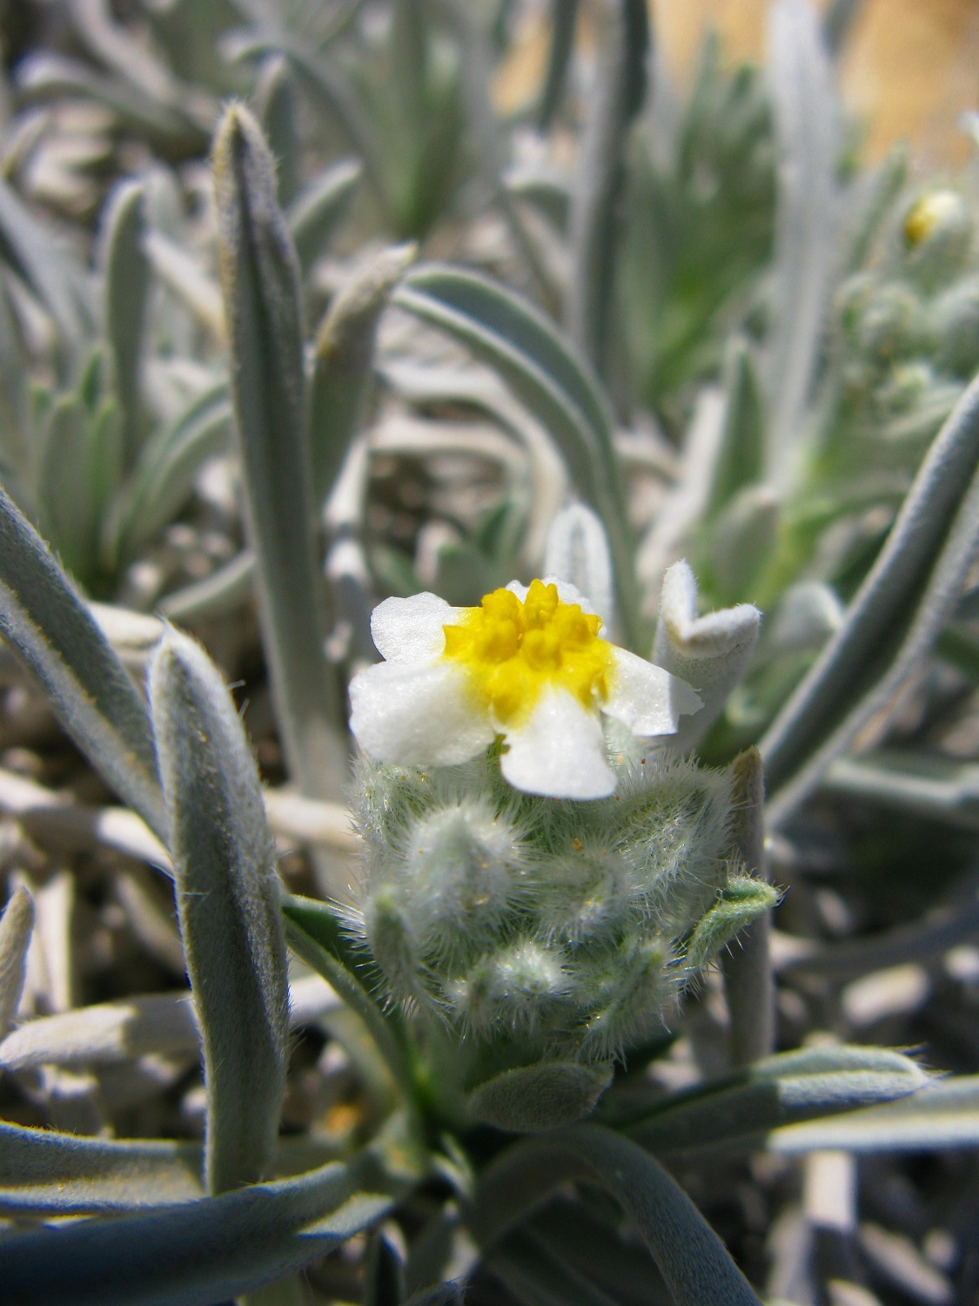
https://tpwd.texas.gov/huntwild/wild/wildlife_diversity/nongame/listed-species/plants/terlingua_creek_cats_eye.phtml

83. Texas Ayenia

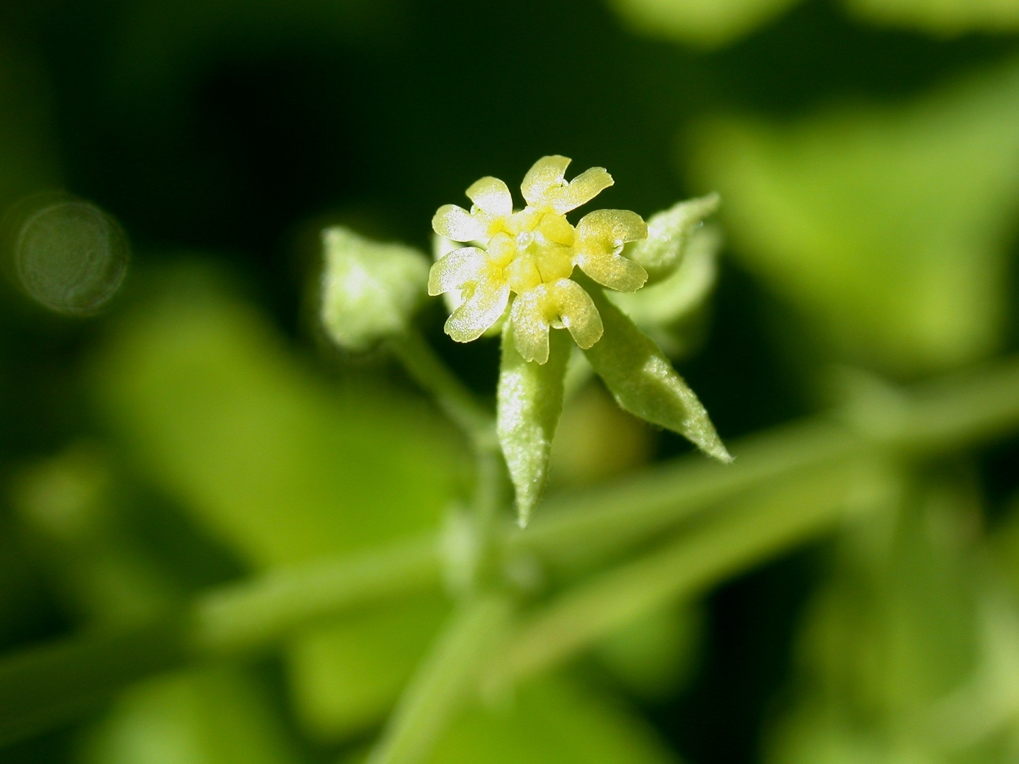
https://tpwd.texas.gov/huntwild/wild/wildlife_diversity/nongame/listed-species/plants/texas_ayenia.phtml

84. Texas Hornshell Proposed Endangered TX, NM
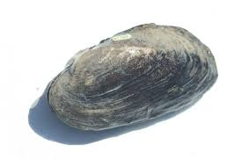
https://ecos.fws.gov/ecp0/profile/speciesProfile?spcode=F02M

85. Texas Snowbells Endangered TX

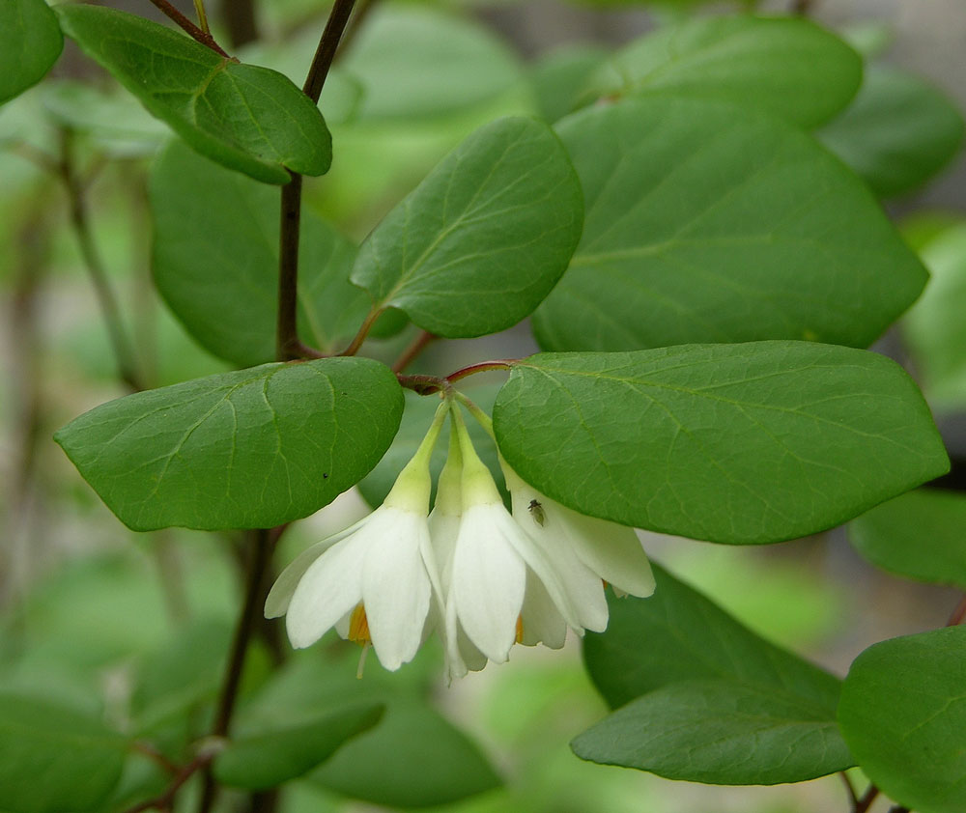
https://tpwd.texas.gov/huntwild/wild/wildlife_diversity/nongame/listed-species/plants/texas_snowbell.phtml

86. Walkers Manioc Endangered TX

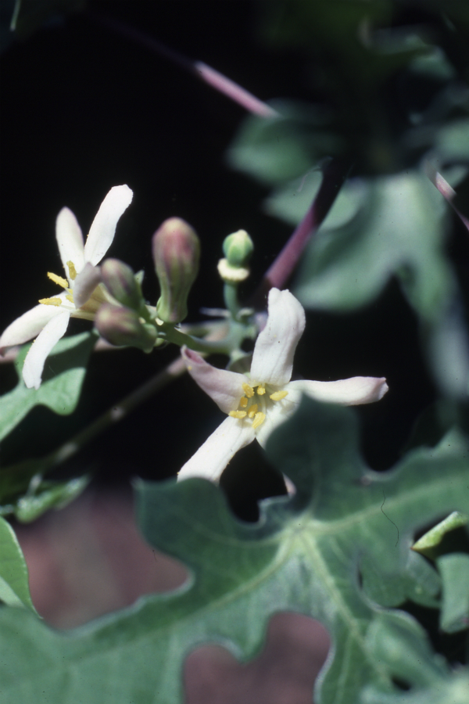
https://tpwd.texas.gov/huntwild/wild/wildlife_diversity/nongame/listed-species/plants/walkers_manioc.phtml

87. Western Snowy Plover Endangered CA

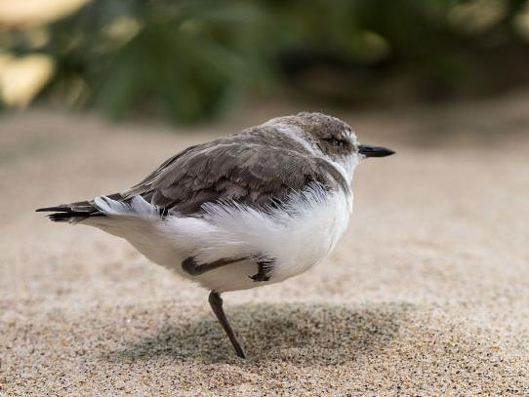
https://www.fws.gov/arcata/es/birds/wsp/plover.html

88. Willowy Monardella endangered CA

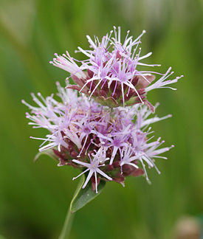
https://calscape.org/Monardella-viminea-(Willowy-Monardella)?srchcr=sc590a07db740dd

89. Wrights Marsh Thistle Candidate AZ, NM

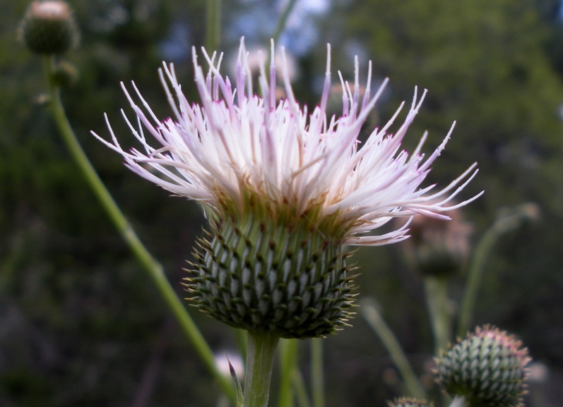
https://ecos.fws.gov/ecp0/profile/speciesProfile?spcode=Q3N3

90. Yaqui Catfish Threatened AZ

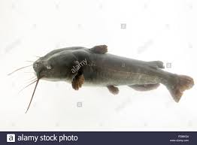
https://e360.yale.edu/features/in-southwest-borderlands-the-yaqui-catfish-faces-its-final-days

91. Yaqui Chub Endangered AZ

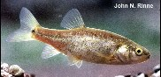
http://www.fishbase.org/summary/Gila-purpurea.html

92. Yellow-billed Cuckoo Threatened AZ NM TX
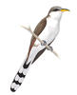
https://www.audubon.org/field-guide/bird/yellow-billed-cuckoo

93. Yuma Clapper Rail Endangered AZ CA

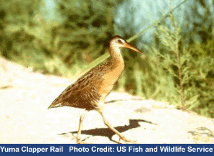

https://ecos.fws.gov/ecp0/profile/speciesProfile?spcode=B00P

94. Zapata Bladderpod Endangered TX

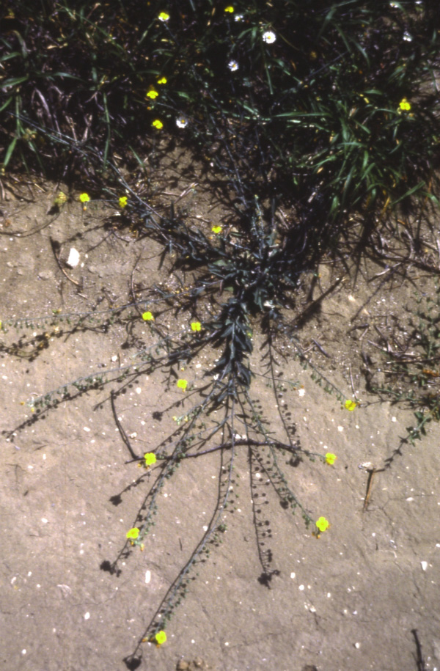

https://tpwd.texas.gov/huntwild/wild/wildlife_diversity/nongame/listed-species/plants/zapata_bladderpod.phtml

